Part-time Officer Guide 2019/20

Contents

Part-time Officer Guide 2019/20 1
Welcome 4
Frequently Asked Questions 5
Contacts and Support 5
Students’ Union Staff Structure 6
National Union of Students (NUS UK) 6
Resources 7
Your Campaigns & Projects 8
What is a Campaign? 8
Communications 9
Social Media 9
Blogging and Articles 9
Email Account 9
Finances 10
What can I spend money on? 10
What can I not spend money on? 10
How do I access and spend money? 11
Timeframe 11
Expenses 11
Events 12
External Speaker Requests 13
Selling event tickets (free or charged) 13
Conferences 14
Accountability 15
#StudentWins 15
Rewards, Awards & Recognition 16
The Leadership Academy 16
SU Carrot Awards 17
Academic Impact Awards 17

Welcome
Congratulations on being elected as a part-time Officer at City, University of London Students’ Union (the Union). This pack contains an overview of the Union, your exciting role up and information of how we will work with you over the year.

The Union exists to represent all 19,000 of our members - every City student. We’re run by students (that’s you), for students, and provide support, representation, advice and activities throughout the good times and the tough times.

We’re governed by a board of 10 Trustees, who work alongside our Student Officers, small staff team, and hundreds of student volunteers to run a thriving and active Students’ Union in the heart of London.

Tuna Kunt
SU President
& Board of Trustees Chair
19/20

Philip Gilks
Chief Executive

Frequently Asked Questions
Firstly, what’s a PTO you say? That’s you, you are a Part-time Officer but sometime we just say PTO because we love acronyms at the SU.

As a PTO you are a volunteer member of the Student Executive Team, a group which meets regularly to discuss activities, campaigns, projects and policies happening on and around campus.

Contacts and Support
As Elected Officers, your line managers are the Students, through Student Members Meetings and Student Council. However, the Full Time Officers can also provide you with direction and support, and the following roles work with the following Officers:

Role | Name | Email | Supports
President | Tuna Kunt | SUPresident@city.ac.uk | Ethics and Environment
CEO | Phil Gilks | Philip.Gilks@city.ac.uk
VP Education | Saqlain Riaz | VPEducation@city.ac.uk | Cass Business SRO  SASS SRO  MCSE SRO  SHS SRO  Law SRO  PG Reps
Representation Manager | Angelo Weekes | Angelo.Weekes.2@city.ac.uk
VP Community and Wellbeing | Rania Salim | VPCommunity1@city.ac.uk | Ethics and Environment Officer  RAG Officer  Sports Officer  Societies Officer  Student Media Officer  LGBT Officer  BME Officer  Disabled Students’ Officer  Women’s Officer  International Students’ Officer
Societies Coordinator | Mark Riley | Mark.Riley@city.ac.uk
Activities & Events Coordinator | Manoj Kerai | Manoj.Kerai@city.ac.uk
Activities and Development Manager | Sophie Harrison | Sophie.Harrison@city.ac.uk
Further information about this can be found in Bye-Law 6: PTOs, as well as more information regarding volunteering with the Union in our Volunteer Policy.

Students’ Union Staff Structure
You can find a full list and contact details for staff here: https://www.citystudents.co.uk/about-us/team/

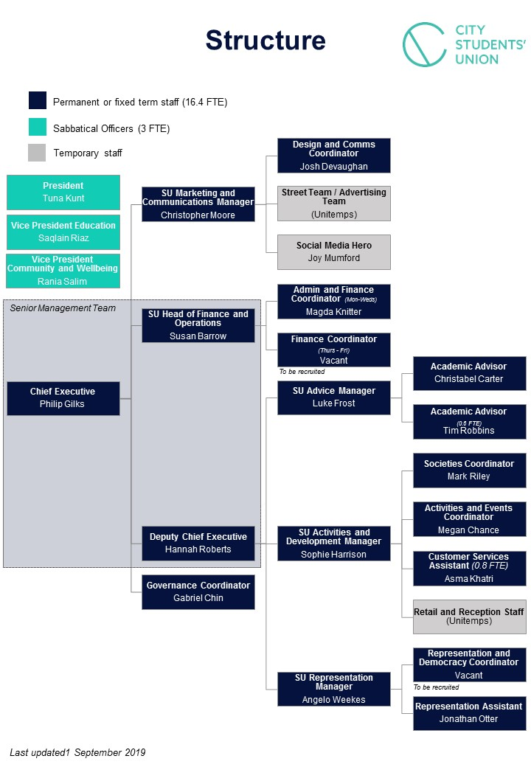

National Union of Students (NUS UK)
The Union is affiliated to the National Union of Students (NUS) which is a confederation of nearly 600 students’ unions. They run a host of nationwide campaigns and projects on student matters and can provide you with support and help with the things you wish to work on. It is their role to ensure the Government and other Higher Education regulatory bodies are held to account and are representative of student views.

There is an Elected Officer to help in each area that works on the kind of things that we work on at City, and their details are here: https://www.nusconnect.org.uk/elected-officers

Some of the key areas which NUS is working with Unions on this year include (but are not limited to:

- The black attainment gap;
- tackling sexual violence on campus and advocating for improved survivor support;
- creating guidance for student tenants;
- sexual health and;
- International students’ mental health.

Resources
When you were elected by students, you were elected to fulfil your manifesto points and to help you do this we can provide you with the space to work.

The Student Hub and office are available for you to use by request during office working hours: Monday to Friday, 10:00 and 17:00, pending approval. To do this you will need to contact Angelo Weekes to book a space.

Your Campaigns & Projects
As an elected representative students have chosen you based on your manifesto pledges and its your job to make sure you deliver on your promises.

What is a Campaign?
Campaigning comes in many forms, but we can generally define campaigning as working in an organised and active way towards a goal.

We are living in rapidly changing times where there is huge scope to make your mark on the world and improve the lives of those around you.

The student movement is one of the most progressive forces for change in the world. Students have been instrumental in global change, turning up in droves to vote in elections, fighting for better housing conditions, liberation, the environment and much more.

As Student Officers, campaigning starts here.

You have all run at least one campaign already – your Election campaigns! Reflect below on what you think made those campaigns successful. If you’ve been involved in other campaigns before, reflect on those too.

The campaign was successful because…
……………………………………………………………………………………………………………………………………………………………………………………………………………………………………………………

I kept my team motivated by…
……………………………………………………………………………………………………………………………………………………………………………………………………………………………………………………

I inspired others by…
……………………………………………………………………………………………………………………………………………………………………………………………………………………………………………………

Who supported you? Are any of them still students? Drop them a line and meet up for a coffee to maintain those relationships so they will support you again.………………………………………………………………………………………………

Communications

Social Media
We recommend that all Social Media be done through your personal accounts. This is to stop student confusion.

As an Officer, you can request for the Union Communications Team to post out information about your work on your behalf onto the main Union Social Media channels and website. To do this you will need to speak with your Officer/ Staff support as listed on the previous page.

Social media is a public audience, and as Officers you may be subjected to unsavoury characters. Please report any incidents of this to Hannah Roberts, Head of Membership Development.

Blogging and Articles
We encourage all Officers to write a brief blog for our Union website, so that students can stay easily updated with what their Officers are doing. This means producing a few bullet points on your activities, and may help with writing your reports for Student Council and Student Members’ Meetings.

If you choose to write a blog or a news piece, you can send this through to Angelo Weekes to have it included on the website and social media channels.

Email Account
You each have an Officer Email account assigned to you for the duration that you are in your Officer position. This is a professional account, and should be treated as such. This is the main account that will be listed on the Union’s website and is the account that students, University staff and externals will use to contact you.

The details for this account have been sent through to you, but if you have any issues with accessing it, please contact Angelo Weekes who will be able to help you access it.

It is recommended that you put the account in your student signature. This will direct staff and students to contact you in this way.

Finances
There is money set aside for Officers to bid to use in order to buy equipment or materials for events, projects or campaigns they wish to run. The total amount available for the year is £5,000, with each Officer allocated a percentage of this budget.

In order to spend any money, you will need to complete a Project Plan and Project Plan Budget, to state what your project will aim to achieve and what you will need money for. All of the documents above can be found on our website within your Resource Hub here.

What can I spend money on?
You can only spend money on things that will be for the benefit of the students you represent. When asking to purchase an item, think about whether you could justify this if questioned by a student as to what you’d spent money on. In the past, money has been given for paint, posters and refreshments.

Quite often, schools or University Departments may also be able to help with funding towards an event or project, and you can ask the Full Time Officers if it is a project they will be able to support from their funds.

What can I not spend money on?
Aside from anything that will not benefit students that you represent, we cannot purchase anything illegal, anything that goes against the Union’s objectives or anything for your own personal benefit.

As a charity, we are unable to donate Union money to another charity. This would be Ultra Vires (beyond our legal power or authority), meaning it would break charity law.

You can organise an event which raises money for charity, or run a raffle, but you will have to source the raffle prizes from other organisations. The Union can advise and support you in organising anything with a charity aspect.

How do I access and spend money?

Timeframe
Please note, we request that all finance forms be completed 4 weeks before you wish to make the purchase.

This means that planning your campaign or project is essential. We recommend you liaise regularly with your Officer and Staff contact, so that they can advise on and support the work you are doing.

Expenses
Expenses are defined as money you have spent personally on activities in your role that you wish to claim back from the Union. Normally, this would be for things like taxi rides to and from train stations and things we cannot buy in advance.

If you have any queries, check with your Officer or Staff contact. Where possible, the Union will buy everything needed in advance.

For any Conference expenses, you will be notified in advance as to how much you are able to claim back.

Events
In order to enable you to deliver on your manifesto points there may be times in the year where you wish to put on events which require booking rooms, stalls, the Bar or Speakers.

In all cases where you wish to run an event your lead Staff Support member should be notified, this is to ensure you are ready and confident to deliver your activity.

All times listed below are on top of the time it is required to gain approval for use of funds, so for example if you wish to have an event with catering you would need to allow a total of six (6) weeks: four (4) weeks for financial approval and two (2) weeks for the food to be ordered and confirmed.

Activity | Notice required | Example of use
Room booking | 2 weeks, or 3 for a weekend | An event or meeting for a campaign group
Stall booking | 2 weeks | A stall for promoting or gathering responses for a campaign
CityBar booking | 2 weeks | An event as part of a campaign, for example networking
CitySport booking | 3 weeks | An active activity as part of a campaign idea
Other University space | 3 weeks | ie. The Courtyard Café for a campaign event
Trips | 3 weeks | A trip to somewhere to educate students about your campaign
External venue hire | 4 weeks (or up to 3 months) the earlier the better | A booking for a large, or specific event outside of University campus
Catering and hospitality | 2 weeks | Food and drink for an activity you have taking place
Risk Assessment for activities above | 2 weeks (usually completed in collaboration with staff support) | All activity must be risk assessed, your staff lead can help with this
External Speaker request | 4 weeks | A panel event to discuss a topic

External Speaker Requests
The Union supports students to create and deliver a wide range of activities, including inviting external individuals with specific knowledge on to campus to speak.

Every individual invited to campus who is not a City University student or staff member must be reviewed to ensure that the Union is managing the risk and responsibilities related to the person(s) invited to campus. To guide us in doing this the Union has a robust process for ensuring the safety of students and staff on campus which is outlined in our External Speaker Policy.

The key information you need to know about this is as follows:

- If you wish to invite a speaker to campus for a campaign, firstly speak with your designated Support Staff member. They will be able to supply you with the relevant form.
- An application for approval of an external speaker must be submitted to the SU Reception Desk at least four (4) weeks prior to the event taking place.
- You cannot advertise a speaker event until you have Union and University approval.
- During its review the Union may request more information about your event, however if you work with your Staff Support member they will be able to help ensure this process is as smooth as possible.

If you wish to run an event with an external speaker we would recommend that you leave at least six (6) weeks to make sure you also have time to advertise it to students.

Selling event tickets (free or charged)
If you are hosting an event you may want to use a ticket system to track the student attending. This can be useful for a number of reasons, including building power and interest after your event for future actions related to your campaign.

If you want to use a free ticket for your event you should do this throughout website. This again, can be organised with your designated Staff Support member.

Conferences

As an Officer, you will automatically be selected to go to corresponding NUS Conferences if they exist, for example, the Women’s Officer will attend the NUS Women’s Conference. If you are unable to attend the conference, let us know as soon as possible so that we may offer conference places to other Executive members.

The NUS National Conference Delegates are elected in autumn, with any places not filled in spring. These positions are open to all students, so if you wish to nominate yourself you should do so when they open.

What other conferences can I go to?
If you want to attend any conference or training event, including any additional NUS conferences, you can apply to go by completing a Project Plan form, and detailing the reasons why it would be beneficial to your role and/or City students for you to attend.

Let us know at least 3 weeks’ in advance of the conference registration deadline, as this will allow us to see if places are available and that we can provide you with accommodation and travel if needed.

Once you have attended the conference, you will need to produce a written report for Union Council, which states your activities at the event and any decisions you participated in.

Do I have to pay?
No. The Union will pay for your travel and accommodation where it is needed. If you let us know your nearest train station, we can try our best to book your ticket from there. Any expenses you occur can be dealt with as detailed in the Finance section of this document.

Accountability
As an Officer, you are accountable to the students who you are representing in your role. This happens predominantly at Union Council and Student Members Meetings.
As such, you will be asked to produce a report of your activities.

For this, you can use the Officer Report Template. This should detail the main things you have been doing in your role and how you have progressed with manifesto pledges. If you’ve done other things outside of your manifesto, this can also be included.

Other ways you can organise activity to let students know what you have been up to include:

- Writing articles for our website or for Carrot Magazine
- Organising recording a short video
- Being interviewed on Carrot Radio
- Attending Society events and talking to students
- Running stalls or campaign activity on campus
- Updating the Executive Team and Student Council on your activity
- Telling us about any wins you have

#StudentWins

We are always looking to shout about student achievements on campus, if you attend a meeting or put something in place that will benefit students across City then tell us! Even the smallest win can make a huge difference.

This year the Union has already seen a number of wins, including:

- Introducing free charging stations on campus
- Increasing funding for Study Well to £7,000
- Sourcing more stationary for the SU Shop at the request of students

Rewards, Awards & Recognition

The Leadership Academy
Take responsibility, organise activity, get yourself accredited. It's that simple.

The Leadership Academy is an initiative funded by Santander, run by the Union with the simple objective of offering accreditation for voluntary roles across the organisation. As a Part-Time Officer you are eligible to complete this programme and we would highly recommend that you do.

The programme allows you to reflect on your time as an Officer, using your experiences to link to nine core principles which future employers will look for when you depart from City.

In short, it develops you and your employability and it’s free! Plus, all your training, meetings and reports can be used as evidence.

Date | Detail | Action required
October | Registration opens | Register to take part in the Academy on our website
November -January | Take part in training and workshops hosted by the Union | Attend activity and reflect on how it helps your role as an Officer
 | Collaborate with others to host activity | Bid for money to run activity with other people completing the Academy
February | Student Leadership Conference | Attend, listen to key speakers, share your year experiences with others
March | Leadership Award Debrief 1 | Reflect on your year and learn how to complete your submission
March | Leadership Award submission deadline | Submit your final piece of work
April | SU Carrot Awards | Come along to celebrate completing your Award and receive your certificate!

More information about The Leadership Academy and how to sign up can be found here: https://www.citystudents.co.uk/getinvolved/leadershipaward/

Any specific questions about this project should be directed to Manoj Kerai who organises the Award.

SU Carrot Awards

Previously known and conducted as two ceremonies this event combines ‘The Carrot Awards’ and ‘The SU Awards’ and are a chance for everyone involved in City Students’ Union to come together to celebrate the year in style.

Nominations for the SU Carrot Awards open on Monday 3rd February 2020, with categories for the event ranging from ‘Student of the Year’ to ‘Best Contribution to Charitable Fundraising’.

Academic Impact Awards

The Academic Impact Awards are your chance to reward the members of staff and students that have helped shape your University academic experience, through their teaching, support, innovation and representation.

This project is delivered in partnership with the University and is a really exciting opportunity to work with colleagues across City to hear about the fantastic work of academics, professional staff and fellow students. Nearer the time there will also be opportunities for you to get involved with the judging panels.

Nominations for the Academic Impact Awards 2019 will open on Monday 27th January 2020.

