Students’ Union President Officer Annual General Meeting Report
An open letter to the students of City
Dear readers,
I hope you’re well, that your studies are going well, and that you’re enjoying your first term of the year at City. For many of you, this hasn’t been the easiest time to be at City. Whether it’s due to the ongoing dust and noise from the building works happening at the front of our university, or whether it’s due to the overcrowding in the hallways during lecture switch-over; I can’t say this year has been easy so far, but I can promise you, things will get better.
The university has many initiatives ongoing, many of which we won’t see completed in our remaining time here at City (Myself included), but I have to say that it is unfair to many of you that the majority of your time at this university has been spent during all of these changes. Many of these changes do have your best interests at heart, but the fact that you’re paying a mountain of fees to have access to an education which is a right for you, not a privilege, makes the impact of this matter all the more serious. I want you all to know that the Students’ Union is here fighting for these changes to be implemented in the best possible way so that the future of this university does continue to have your best interests at heart. From fighting to get back the space that post-graduate students were promised when starting university at City this year in the form of the recently closed graduate library, to taking on a global heavy-weight catering company and the extortionate fees that they charge all of you here at City for food that is essential to fuelling you to perform well in your studies, we’ll always be here to give you a voice and a platform to make the changes that all of you want when here at the university.
I speak as though the SU is a wonderful entity and that we can perform miracles (Which we do albeit occasionally), but the truth is that we’re just a small cog that forms a small part of the massive machine that is City. Yes we make change for students, yes we fight on your behalf for things that the university should give freely to you without being lobbied for, yes we care about you more than any other service/department within this university, but even we fail to deliver sometimes, and for that I am sorry. As many of you will know, City Students’ Union isn’t going through the best time at the moment. We have had a lot of staff leave (Mostly for promotions within other SU’s – And we’re proud of them for that and happy that we could help them on their journey of self-development), and yes we haven’t performed on everything that we should have recently (Societies, I’m talking to you), but I want you to know that we will do better, and we will soon. Just as the university has all of these building works going on externally, we have our own version of the building works going on internally, but I can assure you that this is just a temporary state, and that we’ll be back, bigger and better by the beginning of term 2.
We won’t let this hold us back, we will continue to provide you with as much as we can offer, we will keep on challenging the university on everything that is wrong to students and we won’t stop until we achieve what we set out to do. For although we are just a small cog in the grand scheme of things, one cog that turns against the other components within a machine has the power to change the way that the machine works. The staff within your Students’ Union here are some of the most hardworking and dedicated people that I’ve ever met in my life, and they do it all because they care about you and your studies. Despite us only having a staff team of 8, 3 Full-Time Officers, and 14 Part-Time Officers (A very small team compared to other London SU’s), we still try our best to ensure that you have the best university experience possible.
If you ever need support, advice, have an idea for something great for the university, or even just want a friendly chat, the door to the SU office will always be open for you, so feel free to stop me and say hi if you see me around on campus. At the end of the day, the students here at City are more than just a community, we’re family, and I hope that I’ll make you proud over the remaining 8 months of my Presidency left here at City.
With the warmest of regards,
Your friendly neighbourhood President,
Yusuf Ahmad

The Headlines – My top priorities that I’m currently working on
SU Communications – We’re louder, prouder, and more vocal than before (Where possible)!
Background/Why I’m working on this:
Over the past year, the SU and the communications that we’ve produced have vastly improved in some areas, yet there were still issues that were present in others. Societies have seen a decrease in SU support in promotion of their events previously, and this is where part of this project arose from. Societies especially asked for more support on this and so it has become a priority for myself and the other Officers this year.
Actions that I’ve taken on this:
- Limited actions have been taken on this due to the departure of our Media and Communications Officer
- I have highlighted the need to support society activities through promotion on our Facebook page in SU internal meetings
- Ongoing discussions are taking place about a potential idea that I’ve had – A second SU Facebook page focussed only on promoting SU events, societies, media, and other things that aren’t focussed on elections etc. (Those would continue to go through the main page)
- We are examining our Redbrick research segmentation project data (The survey from last year) to determine more effective ways to communicate with students
- We are looking into implementing new forms of communications such as an SU Snapchat etc.
- We have become more vocal on our SU Facebook page, and have ensured that we’re posting things that are more relevant to students (E.g. society activities on campus, campaigns we’re doing e.g.)

Plan of action going forward:

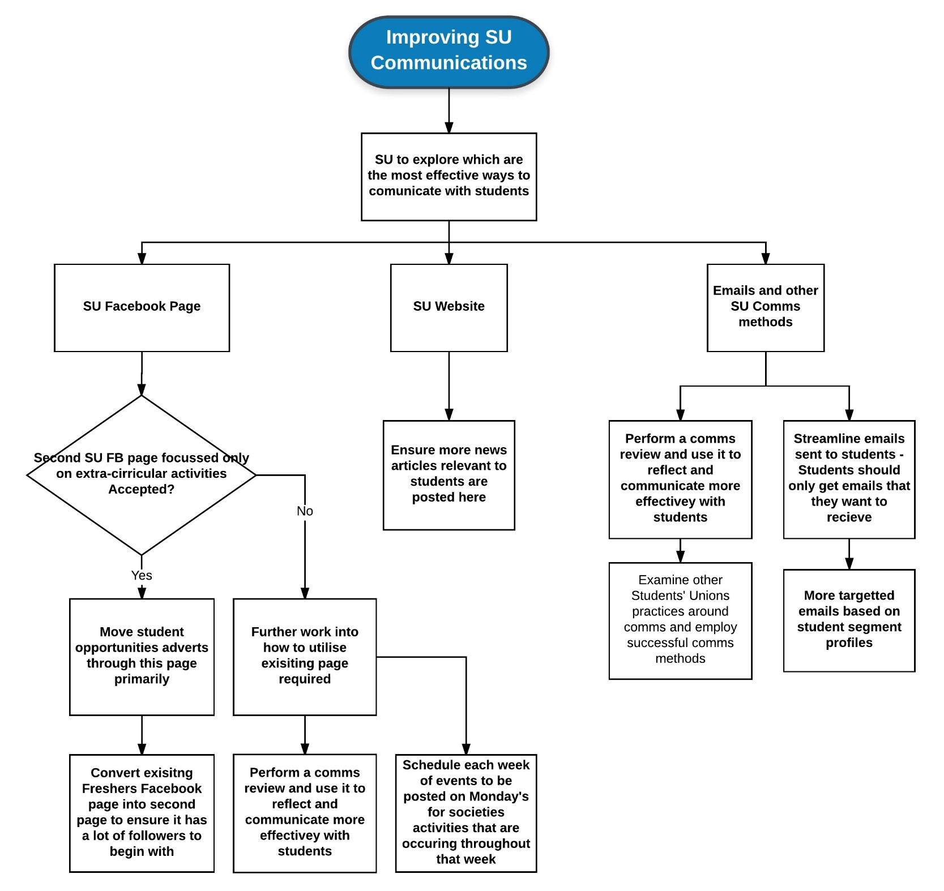

SU visibility on campus – We’re moving to bigger and better spaces, and we’ll try to let you know what we do more on campus!
Background/Why I’m working on this:
Every year, the SU gets feedback that we aren’t visible enough on campus, students don’t know what we do, and in some cases, when we do good things, students think that it was the university that did them. And just to add no, we are not the Bar, and we don’t run the bar!
Actions that I’ve taken on this:
- I have had conversations within the SU to have more banners made for our themed weeks and events (Like the petting zoo that we run every year) so that we can show students that the week/event is an SU initiative
- I am in talks internally within the SU to see if we have funding to get more banners made for societies so that they can raise awareness of who they are more on campus – They deserve recognition!
- I am working on implementing an ‘SU on tour’ initiative from term 2 where the SU spends more time engaging students by visiting the Bunhill Row campus and the Grays Inn campus once a week or every two weeks, as well as having a stall in a central point within the university to talk to more students and to let them know what the SU does, and ask them what they wants us to do
- I have fed in to some decisions being made about the new SU space and offices that we’re moving in to in September 2017 (First floor of the Tait Building)
Plan of action going forward:
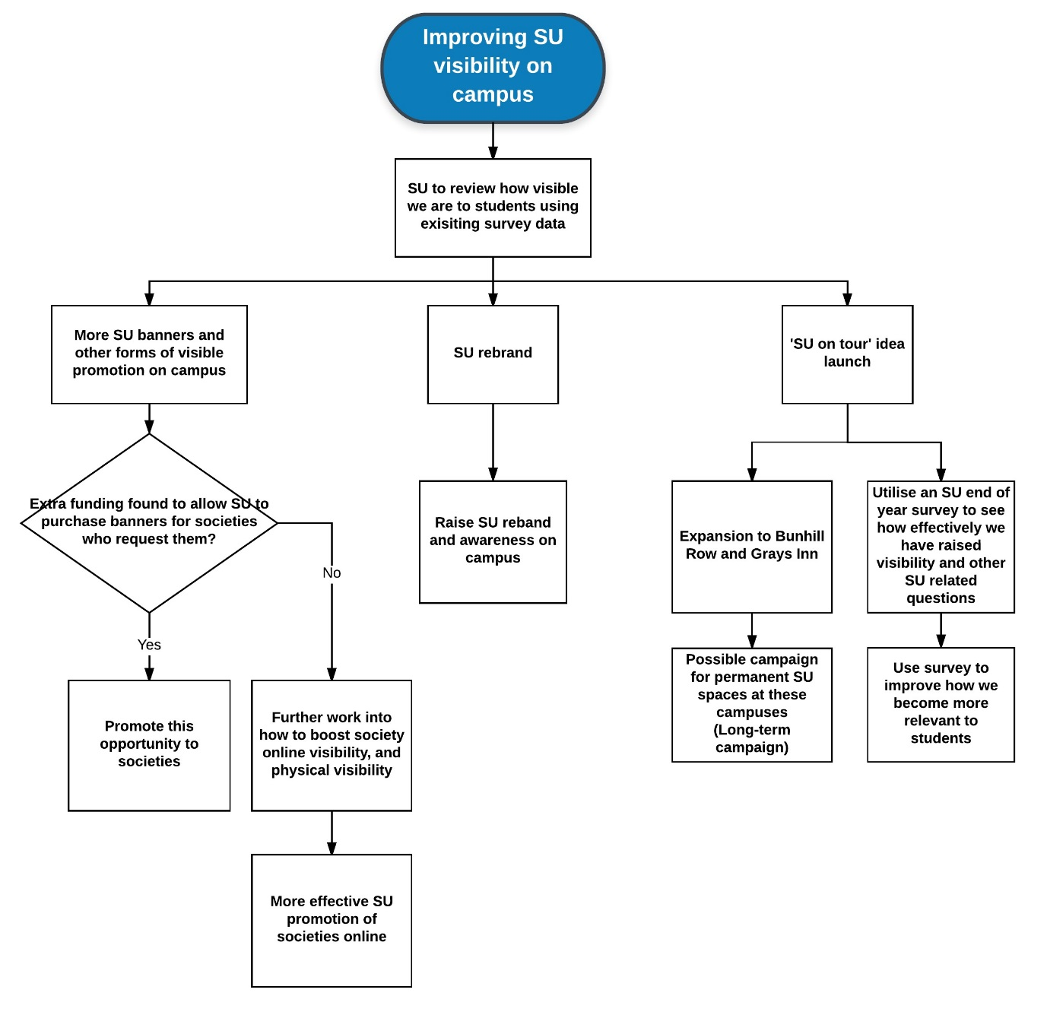

Food Campaign – It’s finally happening! I’ve initiated the first stage of the food campaign that was on my manifesto! It’s time to take the fight to Sodexo.
Background/Why I’m working on this:
This food campaign is based on student feedback that the SU has received over the past year. The feedback came from students on multiple courses and years, through emails to the SU, Student Experience Committees, end of year surveys, and other feedback forums. We then realised the scale of complaints and hence are acting on this to make the differences and change that you asked for.
Actions that I’ve taken on this:
- Two areas have been identified as the primary issues to work on – Pricing of food in the canteen, and also the quality/healthy options of food available within the university
- Several meetings have taken place between the SU and Sodexo since the beginning of this academic year, and the last academic year
- In these meetings, myself and other SU Officers have raised students concerns and feedback on pricing and other aspects of the catering on campus
- I decided to run a survey based on the food available on campus to gather more focussed and detailed feedback (Survey is currently live), and is aimed at providing Sodexo with the necessary feedback, so that the SU can effectively campaign for change
- The data will be analysed by myself and the SU and we will try to produce recommendations and solutions and present them to Sodexo so that they can initiate change based on student feedback from the survey
- If Sodexo refuses to take action, further avenues of action will be pursued
- I have promoted some of the improvements Sodexo have made on campus in terms of student offers - £3 meal in the canteen etc. to show students that changes are being made

Plan of action going forward:

Staff recruitment – We’ve been busy recruiting, and we’re nearly back at full strength!
Background/Why I’m working on this:
As mentioned in the open letter to students at the beginning of these papers, a lot of SU staff have left the SU (Mostly for good reasons such as promotions elsewhere), and so a large part of my time has been spent recruiting new staff to support the SU in the foreseeable future.
Actions that I’ve taken on this:
- I was the Chair of the recruitment panel tasked with recruiting a new CEO for the SU – and we were successful with a new CEO who has already started
- I was on the recruitment panel for a new Business Operations Manager for the SU – and we successfully recruited a new staff member who is starting soon
- I was responsible for the interview and appointment of a new student trustee member who has now joined our SU Trustee Board
- I edited and wrote part of the recruitment pack and devised a timeline for a new Membership Development Manager role within the SU
Note to students:
Recruitment sounds like a quick process, and in some cases it is, but these past few months have been challenging to say the least. SU’s usually have maybe one or two staff who leave a year (Depending on their size), however, we had 5 staff leave over the past 4 months which is a massive staff turnover (Considering we only have 8 full-time staff members), and so a lot of the staff and Officers time over the past months has been spent trying to hold the SU together, and recruit the missing staff. I hope that you understand the struggles we have faced, and that we will be stronger and deliver more for you soon. We appreciate your continued patience and support.

Campaigning for increased social space on campus – Campaigning for the space that you not only need, but you deserve!
Background/Why I’m working on this:
Everyone knows that City isn’t the best university for having social spaces on campus. Students have fed this back to the university time and time again, and also to the SU, and we’re trying to make this a reality.
Actions that I’ve taken on this:
- Using the committees that I sit on, I have expressed the need for more social space on campus, and the university is trying to make this happen
- Using my knowledge of new university buildings that are being constructed, I am ensuring that the university builds more social spaces where possible within these buildings
- I noticed that the university didn’t have any student representation on a project board for a new building project that they’re about to start, and I insisted that the SU President was included in the membership of this board so that I, and my successors could all work on ensuring the university builds more social spaces on campus

What else have I been up to besides this?
Faith issues on campus
I have been continuing the work around the Friday Prayer campaign and Friday Prayer is now back on campus and happening every week! We are still working on this to maintain that it is reflective of the student’s interests and trying to make sure that it is easy as possible by working with the university on this. The next step is to try and find a place for Friday Prayer to happen during exam times, and I will be looking into working with the university to find a suitable alternative to the Great Hall during this period.
Besides this, I am beginning to approach other faith groups and societies on campus to ask them what faith provisions/projects they want to see the SU campaign for them next – So if you’re reading this and have an idea for me, be sure to let me know!
Input in to key decisions that the University is making
This has been a slow process right now as our referendum procedures are currently being re-worked to reflect the changes that we’re going through as a Union and a university, however, this will be picking up in term 2 as we will be providing more details on what the university has planned in terms of building projects and refurbishments, and other major changes.
Transparency of high level university staff
This is on its way to starting. Once the SU student media is up and running, I will be (With the permission of the University Executive Team and the SU Student Media society!) be setting up a column in which I write in fortnightly called ‘Curran Affairs’ (Based on the University President’s name Paul Curran), and this will be aimed at providing students with more of an insight into who the Executive Team at the University are, and what they do.
Graduate Library closure
As of the 30th September, the university made the decision to close down the Graduate Library due to the Sebastian Street project as it is located in the current site of some construction that is due to take place. This has resulted in many Postgraduate students (Specifically Postgraduate Taught/Masters students) being left without a dedicated space to study and are hence very unhappy. I have been leading on the work to get an alternative space provided for Postgraduate students to study in. The SU and the university are currently looking into alternate spaces for use as a replacement to this missing library, as currently, the main library provisions will become insufficient when the January exam period hits. To add a bit of context to this, the Graduate Library had 50 desks (Some of which had computers), and these saw roughly a few hundred students use them at the peak of its use. The SU is determined to ensure that the university finds an alternate space for use for the Graduate Library, as it will otherwise cause frustration of the main library being too congested, as Undergraduate students won’t have enough space to study. The SU currently has a survey online to gather Postgraduate student feedback on this to gather data on why Postgraduate students require this space – It so far has over 70 responses in under a week.
And just keeping up the fight in other areas
In addition to all of the above, the following has also been achieved:
- The SU Full-Time and Part-Time Officers raised concerns about the lack of student representation on the university’s project to reform student facing communications (And reforming other things), and the university listened and put student representation on the oversight board for this project
- I stated that I wasn’t happy with the university raising international student’s fees over the next few years in an Executive Committee meeting, but was shut down on this as the university increased it anyway – I still tried though!
- I have raised students complaints based on lockers and their unfair usage, the lack of microwaves next to the canteen, and other things to the university on behalf of students

